Team Quaternary:

ST10019838 - Damian Dare

ST10019972 - Guillaume Swanevelder

ST10091991 - Christiaan Versfeld

ST10158660 - Ruan Zwarts

Module: XBCAD7319

Lecturer: Ms. Mmaphuti Matau

Documentation: Analysis Artifacts

Table of Contents

1. ANALYSIS ARTIFACTS 3

1.1. Domain Modelling 3

Description of Each Bounded Context 3

1.2. Design Artifacts 5

REFERENCE LIST 8

References 8

# 1. ANALYSIS ARTIFACTS

To evaluate these requirements and develop a domain model utilising a Domain-Driven Design (DDD) methodology, it is essential to identify the many constrained contexts within the system.

## Domain Modelling

## Description of Each Bounded Context

1. User Management Context

* Manages user authentication (login/logout) and access control.
* Supports CRUD operations for user profiles.
* Administers several roles (Client, Coach, Admin) and their associated rights.

1. Lesson Booking Context

* Manages class scheduling, encompassing the selection of dates and time periods.
* Imposes regulations regarding lesson accessibility according to user proficiency and coach allocations.
* Oversees booking particulars and interacts with the Lesson Management framework to obtain lesson data.
* Guarantees that booking confirmations and updates are conveyed to users through the Notification context.

1. Payment Management Context

* Displays payment information and allows for payment processing.
* Integrates with external payment gateways to manage electronic funds transfers and alternative payment methods.
* Monitors payment status and preserves records of payment history for each user.

1. Lesson Management Context

* Enables Coaches and Administrators to create, amend, and delete lessons.
* Administers lesson metadata, including descriptions, locations, schedules, and coach details.
* Facilitates the assignment of levels/ranks to clients for skill-appropriate lesson planning.

1. Notification Context

* Manages the sending of notifications for various events, such as lesson bookings, payment confirmations, or lesson cancellations.
* Provides customizable notification templates for different types of alerts.

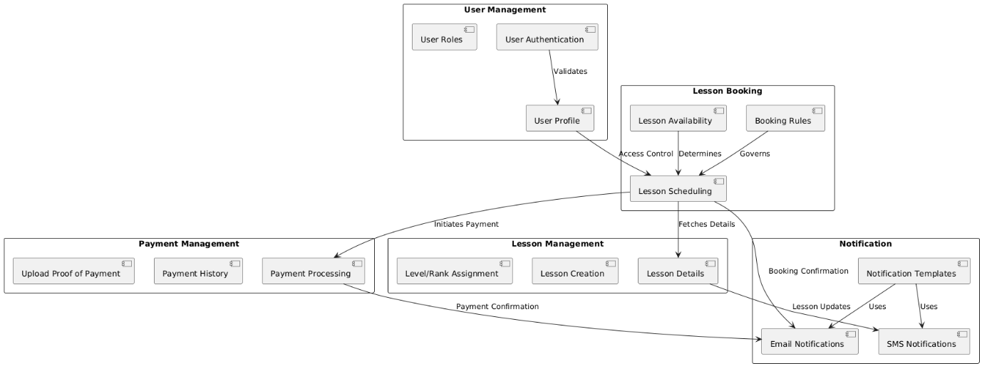

(PlantText, 2024)

## Design Artifacts

Analysis of the Domain Model

The domain model is constructed according to the requirements, encompassing essential components such as user roles, lesson bookings, lesson specifics, and payment administration. We will convert these into implementation models comprising classes, relationships, and interactions to satisfy the specified user stories.

Implementation Model Design

* User Roles and Permissions: Define user access levels for Client, Coach, and Admin.
* Lesson Management: Organize how lessons are created, scheduled, and booked.
* Payment Processing: Implement payment processing and proof-of-payment uploads.
* User Interface Components: Design UI interactions for booking lessons and viewing details.

**Sequence Diagram of Lesson Management**

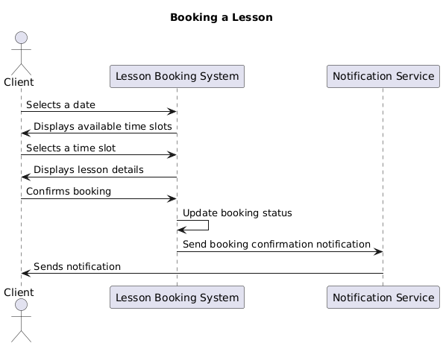

(PlantText, 2024)

**Sequence Diagram of Payment Processing**

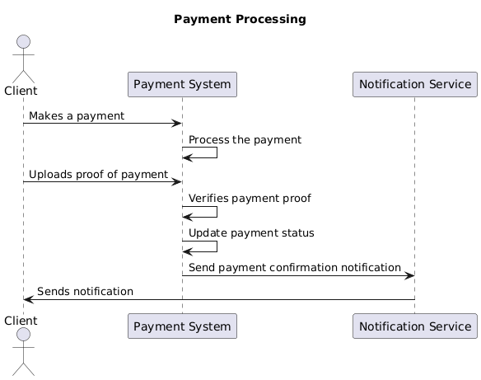

(PlantText, 2024)

# REFERENCE LIST

# References

PlantText, 2024. *PlantUML.* [Online]   
Available at: https://www.planttext.com/  
[Accessed 24 10 2024].